The Title of the Abstract Should Be Times New Roman Font, Size 12, Bold and Centered
The author name and affiliation should be size 10, italics and underneath the title.
(e.g. John Smith, SEG Middle East)

Introduction

The font for this template is Times New Roman, but any comparable font may be substituted. The Section Headings are 9-point bold Times New Roman and the text of the paper is 9-point Times New Roman.

Abstracts should be sent in PDF to the 21st IWSA organizing committee. The organizing committee staff will not edit or retype the data on the abstract. The maximum length of an abstract is 2 pages.

Theory and/or Method

All paragraph text should be set for full justification. Note that paragraphs are not indented and are separated by one line of space. Additional instructions for composition are:
- Abstracts must be written in English.
- Authors are responsible for sizing and positioning their illustrations.
- Figures can be in black and white or color.
- Figures, equations, charts, graphics, etc. must be embedded into the text of the paper.

Examples

If you have a chart, graphic, equation, etc. you will need to embed them in the document. You can insert a frame and place a caption inside.

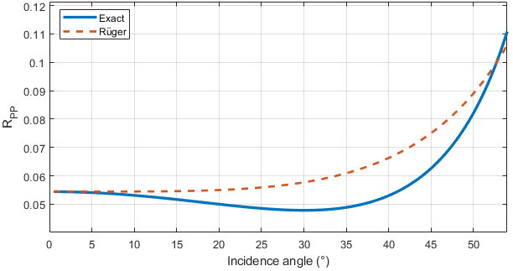

Figure 1: This caption is placed inside the frame. This is an example of a figure related to seismic anisotropy analysis.

You can place the caption inside or outside the frame. Place your cursor where you want the caption by left clicking once, select References from the menu bar, select Insert Caption. Choose the label (Figure, Table, or even create your own label) and format the numbering sequence.

Conclusions

All abstracts must include a conclusion in order to end your research/case study. This would be useful for the reader to understand what the result was of the information you have provided throughout the abstract.

